Process Definition Document (PDD)

*Process Name: BYO Recipe Scraper*

Table of Contents

**Introduction** **1**

Purpose of the Document 1

Objectives 1

Process Key Contact 1

Minimum Prerequisites for Automation 1

**As-Is Process Description** **2**

Process Overview 2

Applications used in the Process 3

As-Is Process Map 3

**To-Be Process Description** **3**

Detailed Process Map 3

Robot Type 4

Business Exceptions Handling 4

Known Exceptions 4

Unknown Exceptions 4

System Exceptions Handling 4

**Other Observations** **5**

**Additional sources of process documentation** **5**



# Introduction

## Purpose of the Document

The Process Definition Document outlines the business process chosen for automation using UiPath Robotic Process Automation (RPA) technology.

The document describes the sequence of steps performed as part of the business process, the conditions and rules of the process prior to automation and how they are envisioned to work after automating it, partly or entirely. This specifications document serves as a base for developers, providing them with the details required for applying robotic process automation to the selected business process.

## Objectives

The business objectives and benefits expected by the Business Process Owner after automation of the selected business process are:

* Automates the update of master Google Sheet of all-grain beer recipes

## Process Key Contact

The specifications document includes concise and complete requirements of the business process and it is built based on the inputs provided by the process Subject Matter Expert (SME)/ Process Owner.

The Process Owner is expected to review it and provide signoff for accuracy and completion of the steps, context, impact and a set of process exceptions. The details are to be included in the table below.

|  |  |  |  |
| --- | --- | --- | --- |
| Role | Name | Contact Details  (email & phone number) | Notes |
| Process Owner | Jes Hunsballe | N/A | N/A |
| Business Analyst | N/A | N/A | N/A |

## Minimum Prerequisites for Automation

|  |  |
| --- | --- |
| Met (Y/N) | Prerequisites |
| Y | A filled in and completed Process Definition Document |
| Y | Closure of any open process questions |
| Y | Environment set up |
| Y | Test Data to support development and testing |
| Y | User access and creation of user accounts (licences, permissions, restriction to create accounts for robots) |

# As-Is Process Description

## Process Overview

General information about the process selected for RPA prior to automation.

|  |  |  |
| --- | --- | --- |
| # | Item | Description |
| 1 | Process Full Name | BYO Recipe Scraper |
| 2 | Process Area | Hobby |
| 3 | Department | Hobby |
| 4 | Process Short Description  (operation, activity, outcome) | Dispatcher: Reads beers off byo.com all-grain search page, compares them to already known beers and then adds new beers only to Orchestrator queue.  Performed: Scrapes all-grain beer recipes for the beers in the Orchestrator queue off byo.com and adds the receipes to a master Google Sheet. |
| 5 | Role(s) required for performing the process | None |
| 6 | Process schedule and frequency | Manually when in the mood for brewing something new |
| 7 | # of items processed /reference period | Initially ~1100 recipes scraped in master sheet in ~1½ hour |
| 8 | Process execution time | New identified beers are identified in seconds per beer and scraped and saved to the master sheet in seconds. |
| 9 | Peak period(s) | N/A |
| 10 | Transaction Volume During Peak period | N/A |
| 11 | Total # of FTEs supporting this activity | N/A |
| 12 | Expected increase of volume in the next reference period | Not many new beers are added to the byo.com beer page every monthly. |
| 13 | Level of exception rate | Unknown. |
| 14 | Input data | Master Google sheet with known beer details.  Beer card details from byo.com web page.  Beer recipes from byo.com beer web page.  Mail template html files in \Mail folder. |
| 15 | Output data | Beer details and recipe in a beer master Google Sheet (one beer per row).  Beer details in the output are: Beer name, beer url, beer description, beer style(s), beer recipe.  Email sent to user with new beers identified. |

*Add more rows to the table to include relevant data for the automation process. No fields should be left empty. Use “n/a” for the items that don't apply to the selected business process.

## Applications used in the Process

The table includes a comprehensive list of all the applications that are used as part of the process to be automated to perform the given steps in the flow.

|  |  |  |  |  |  |
| --- | --- | --- | --- | --- | --- |
| # | Application Name & Version | System Language | Thin/Thick Client | Environment/ Access Method | Comments |
| 1 | MS Windows 10 Home 64bit v10.0.19042 Build 19042 | English |  |  |  |
| 2 | Chrome v88.0.4324.150 (Official Build) (64-bit) | English |  |  |  |
| 3 | UiPath Studio 2019.10.5 | English |  |  |  |
| 4 | UiPath Web Automation plugin for Chrome v9.0.6824 | N/A |  |  |  |

*Add more rows to the table to include the complete list of applications.

## As-Is Process Map

**High Level As-Is Process Map:** This chapter depicts the As-Is business process at a High Level to enable developers to have a high-level understanding of the current process.

**Detailed Process Map:** This chapter depicts the As-Is business process at a detailed view to enable process owners to document their process

|  |  |  |  |
| --- | --- | --- | --- |
| # | Step Action/Description | Screenshot | Remarks |
| 1 | Open byo.com |  | Manual step |
| 2 | Login to byo.com |  | Manual step |
| 3 | Navigate to search and search for desired beer |  | Manual step |
| 4 | Click beer url |  | Manual step |
| 5 | Copy and paste beer name, beer url, beer description, beer recipe to master sheet |  | Manual step |
| 6 | Log out of byo.com |  | Manual step |

# To-Be Process Description

## Detailed Process Map

**High Level To-Be Process Map:** This chapter depicts the To-Be automation process at a High Level to enable developers/COE to have a high-level understanding of the to be developed process.

***Dispatcher:***

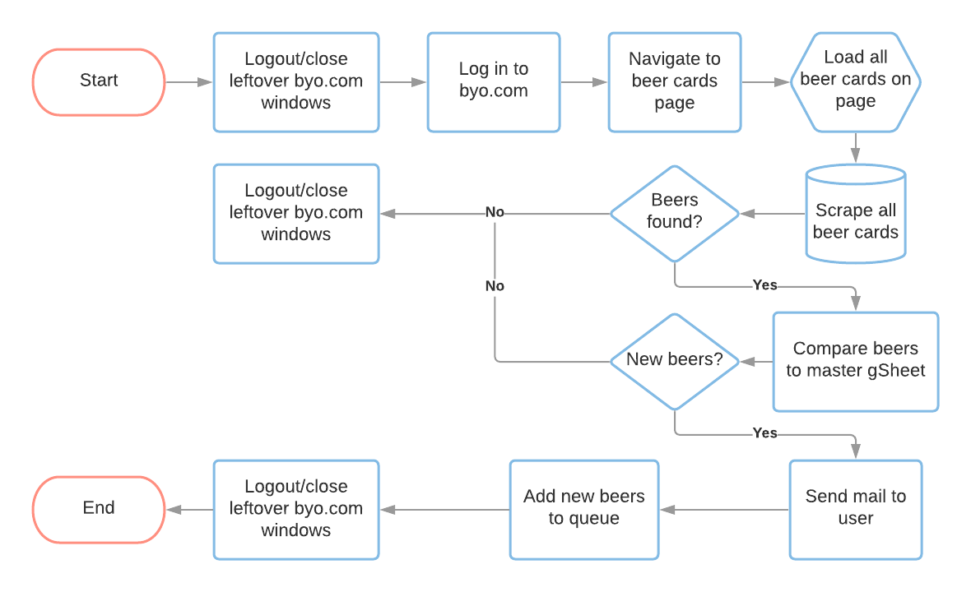

***Performer:***

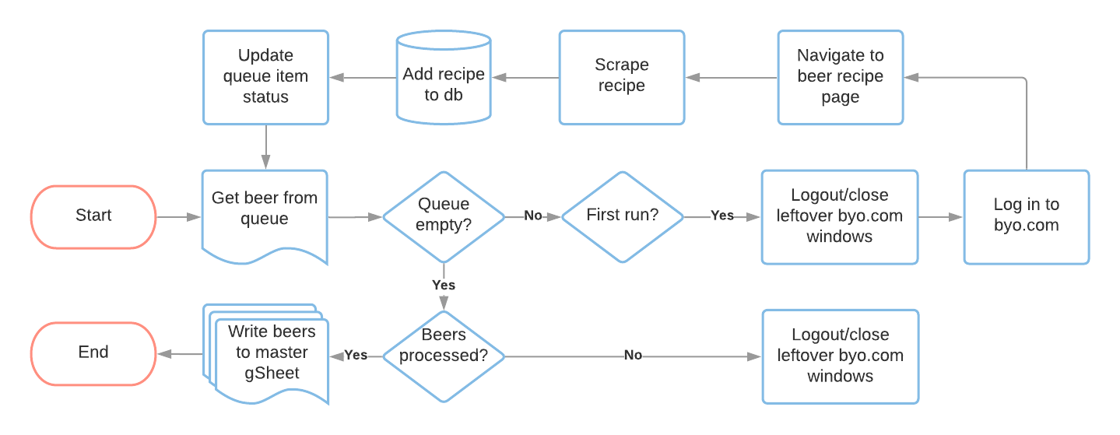

**Detailed Process Map:** This chapter depicts the To-Be automation process at a detailed view to enable developers/COE to see the workflows involved in the RPA solution

|  |  |  |  |  |  |
| --- | --- | --- | --- | --- | --- |
| **Workflow Name** | **Description** | **Pre-conditions** | **Post-actions** | **Arguments** | **Notes** |
| BYO_logIn | Open BYO login page in Chrome, log user in. | N/A | User logged in and navigated to BYO login page in Chrome browser. | None | Orchestrator assets: BYO_credentials, BYO_allGrainBeers  https://byo.com/?s=&recipe-type%5Ball-grain%5D=all-grain&post_type=recipe |
| BYO_logOutAndCleanUp | Log out and clean up left over browsers | N/A | All BYO windows closed and user logged out. | None |  |
| BYO_loadBeerCards | Ensure all recipe cards load on screen | Logged in and navigated to beer cards page (recipes search area) on byo.com. | User logged in and navigated to BYO beer cards page in Chrome browser. | None | Exception/retry handling/find out to catch when it stops |
| BYO_scrapeBeerCards | Scrape details from recipe cards once all loaded | Logged in and navigated to beer cards page (recipes search area) on byo.com. | User logged in and navigated to BYO beer cards page in Chrome browser. | out_dt_beerCardDetails - datatable | Extract beer name, url, short description, style block (expand further to beer style with regEx) |
| BYO_getNewBeers | Check scraped beer urls against master beer recipe collection gSheet and only add beers to Orchestrator queue if they were not already in the gSheet. | GSuite Application Scope needs an API service account json key stored externally on user drive. gSheet must be shared to the Service Account e-mail. | N/A | in_dt_scrapedBeers - datatable out_dt_newBeers - datatable | Make queueItem with beer name, url, short description, style(s). Use GSuite Application Scope and access gSheet with API service account json key stored externally on own drive. gSheet must be shared to the Service Account e-mail. |
| BYO_dispatchBeers | Add scraped beer card details from beer cards page on byo.com to an Orchestrator queue | N/A | N/A | in_dt_newBeers - datatable |  |
| mail_sendGMail | Send new recipe names, styles and urls from datatable by gmail to myself | N/A | N/A | in_dt_newBeers - datatable | Base mail on template and build html table part with new beers. |
| BYO_scrapeBeerRecipe | Get beer url from queue item, navigate to beer recipe page and scrape full recipe. | User logged in to byo.com in Chrome browser. | User logged in and navigated to BYO beer recipe page in Chrome browser. | in_transactionItem_newBeer - queueItem out_beerRow - array out_status - string out_failReason - string |  |
| BYO_queueItemUpdate | Update queue item with relevant status depending on recipe scraping success or failure. | N/A | Queue item status set to 'Successful' or 'Failed' | in_transactionItem_newBeer - queueItem in_status - string in_failReason - string |  |
| BYO_updateMasterSheet | Append recipes from datatable to master recipe collection gSheet | N/A | N/A | in_dt_newBeers - datatable | Use Gsuite Read Range to get last row, then append with Write Range from last row+1 as starting cell. |

## Robot Type

|  |  |  |  |  |
| --- | --- | --- | --- | --- |
| # | Attended | Unattended | Trigger | Comments |
| 1 | Attended | N/A | N/A | N/A |

## Business Exceptions Handling

The Business Process Owner and Business Analysts are expected to document below all the business exceptions identified in the automation process. These can be classified as:

### Known Exceptions

The table below reflects all the business process exceptions encountered during the process evaluation and documentation. These are known exceptions that occurred before. For each of these exceptions, define a corresponding expected action that the robot should complete if it encounters the exception.

|  |  |  |  |  |
| --- | --- | --- | --- | --- |
| BE # | Exception Name | Step | Parameters | Action to be Taken |
| 1 | Log in exception | BYO_logIn |  | Stop execution |
|  |  |  |  |  |
|  |  |  |  |  |

### Unknown Exceptions

For all other unanticipated or unknown business (process) exceptions, the robot should:

* Log Warning and exception source+messageand send send screenshot to process owner

## System Exceptions Handling

A comprehensive list of all errors, warnings or notifications should be consolidated here with the description and action to be taken, for each, by the robot.

Errors identified in the automation process can be classified as:

|  |  |  |  |  |
| --- | --- | --- | --- | --- |
| SE # | Exception Name | Step | Parameters | Action to be Taken |
| 1 | Closing BYO browser windows and logging out | BYO_logOutAndCleanUp |  | Log Warning and exception source+message. |
| 2 | Issue when scraping beers / extracting structured data from byo webpage | BYO_scrapeBeerCards |  | Log Fatal error and exception source+message. |
| 3 | Google sheet access issues | BYO_getNewBeers / BYO_updateMasterSheet |  | Log Fatal error and helpful message and exception source+message. |
| 4 | E-mail body template html file loading issue | mail_sendGMail |  | Log Fatal error and helpful message and exception source+message. |
| 5 | E-mail sending issue | mail_sendGMail |  | Log Warning error and helpful message and exception source+message. |
| 6 | Issue on bulk upload new beers to Orchestrator queue | BYO_dispatchBeers |  | Log Fatal error and helpful message and exception source+message. |
| 7 | Issue scraping recipe from byo beer webpage | BYO_scrapeBeerRecipe |  | Log Warning error and exception source+message. Carry this warning over as a failed reason for the downstream Orchestrator queueItem status update. |

For all the other unanticipated or unknown system exceptions, send an email to **<process owner>** and attach a screenshot of the error message.

# Other Observations

Include below any other relevant observations you consider needed to be documented here.

# Additional sources of process documentation

* Whiteboard.xlsl file in project folder root
* Development Specifications Document in project root folder